GESTURE CONTROLLED ROBOT

Project Report

Submitted in the partial fulfillment of requirement for award of degree

of

Bachelors of Technology

In

Electronics and Communication Engineering

Presented at



University School of Information and Communication Technology

Guru Gobind Singh Indraprastha University

Sector 16C, Dwarka, New Delhi

SUBMITTED BY:

Paras

09016412812

Rahul Thakur

08316412812

B.Tech (Electronics and Communication Engineering) – 5th Semester

University School of Information and Communication Technology

**CONTENTS**

1. AIM
2. ACKNOWLEDGEMENT
3. APPARATUS REQUIRED
4. DESCRIPTION
5. INTRODUCTION TO ATMEGA 16
6. ACCELEROMETER
7. RF COMMUNICATION MODULE
8. LCD
9. DC MOTORS
10. CHASIS BOARD
11. TRANSMITTER
12. ENCODER
13. RF TRANSMITTER MODULE
14. RECIEVER
15. DECODER
16. CODE OF THE PROGRAM
17. APPLICATION
18. CONCLUSION
19. REFERENCE
20. APPENDIX

**AIM:**

**To design a Hand controlled / Gesture controlled robot**

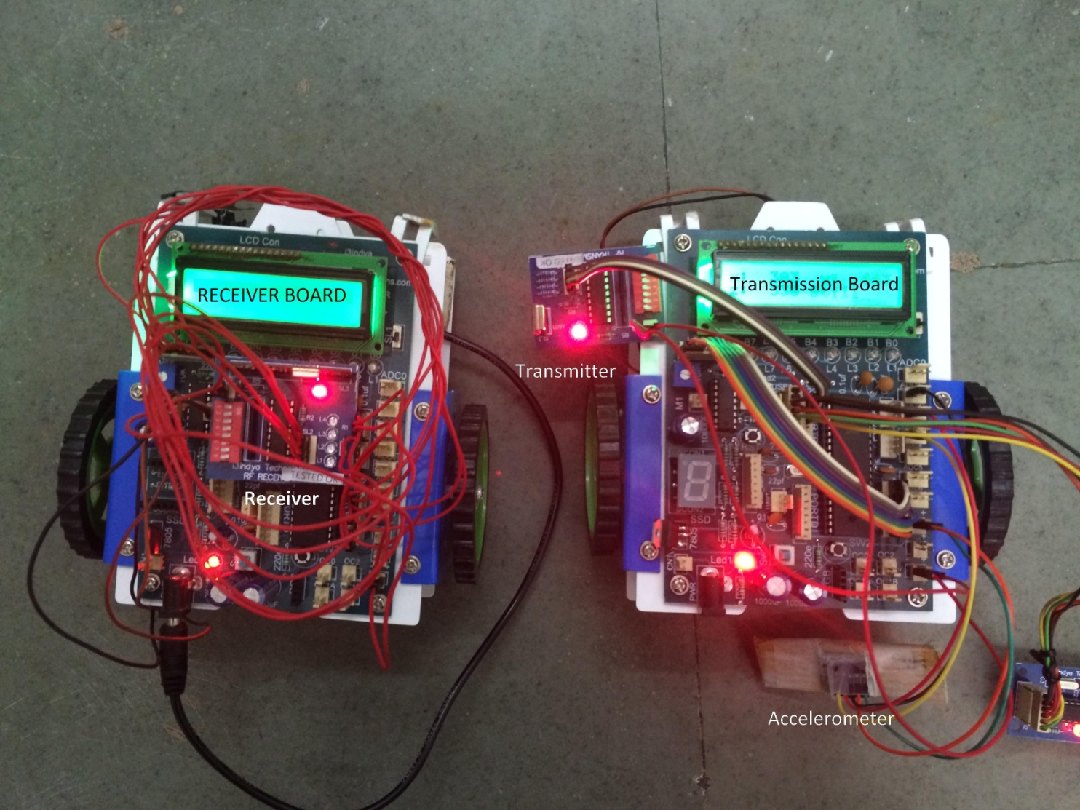

Figure 1: Final project view

ACKNOWLEDGEMENT

I would like to take this opportunity to thank i3Indya Technologies for providing me with this opportunity to learn Embedded System and Robotics.

Also I would like to thank our instructor, Mr. Ashish Raina for his patience and time while teaching us Embedded Systems and Robotics.

**Apparatus required:**

* 2 Atmega 16 IC with board
* Accelerometer
* RF module ( receiver and transmitter along with module )
* LCD for displaying the motion
* 2 DC motors
* Wires (female to female)
* Chassis ( for designing it like a robo car)

**Description**

A **Gesture Controlled robot** is a kind of robot which can be controlled by  your hand gestures not by old buttons. You just need to wear a small transmitting device in your hand which included an acceleration meter. This will transmit an appropriate command to the robot so that it can do whatever we want. The transmitting device included a  ADC for analog to digital conversion and an encoder IC(HT12E) which is use to encode the four bit data and then it will transmit by an RF Transmitter module.

At the receiving end an RF Receiver module receive's the encoded data and decode it by and decoder IC([HT12D](http://www.engineersgarage.com/electronic-components/ht12d-datasheet)). This data is then  processed by a microcontroller  and finally our motor driver to control the motor's.  Now its time to break the task in different module's to make the task easy and simple any project become easy  or error free if it is done in different modules. As our project is already divided into two different part transmitter and receiver. We will discuss both of them one by one.

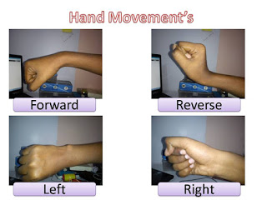

Figure 2: Hand gestures

**Atmega16**

**Atmega16 introduction:**

ATmega16 is an 8-bit high performance microcontroller of Atmel’s Mega [AVR](http://www.engineersgarage.com/articles/avr-microcontroller) family with low power consumption. Atmega16 is based on enhanced RISC architecture with 131 powerful instructions. Most of the instructions execute in one machine cycle. Atmega16 can work on a maximum frequency of 16MHz. ATmega16 has 16 KB programmable flash memory, static RAM of 1 KB and EEPROM of 512 Bytes. The endurance cycle of flash memory and EEPROM is 10,000 and 100,000, respectively.

ATmega16 is a 40 pin microcontroller. There are 32 I/O (input/output) lines which are divided into four 8-bit ports designated as PORTA, PORTB, PORTC and PORTD. ATmega16 has various in-built peripherals like  [USART,](http://www.engineersgarage.com/embedded/avr-microcontroller-projects/serial-communication-atmega16-usart)  [ADC,](http://www.engineersgarage.com/embedded/avr-microcontroller-projects/adc-circuit)  [Analo](http://www.engineersgarage.com/embedded/avr-microcontroller-projects/analog-comparator-circuit)g  [Comparator,](http://www.engineersgarage.com/embedded/avr-microcontroller-projects/analog-comparator-circuit)  [SPI,](http://www.engineersgarage.com/embedded/avr-microcontroller-projects/spi-serial-peripheral-interface-tutorial-circuit)  [JTAG](http://www.engineersgarage.com/embedded/avr-microcontroller-projects/disable-jtag-port) etc. Each I/O pin has an alternative task related to in-built peripherals.

The ATmega16 provides the following features: 16 Kbytes of In-System Programmable Flash Program memory with Read-While-Write capabilities, 512 bytes EEPROM, 1 Kbyte SRAM, 32 general purpose I/O lines, 32 general purpose working registers, a JTAG interface for Boundary-scan, On-chip Debugging support and programming, three flexible Timer/Counters with compare modes, Internal and External Interrupts, a serial programmable USART, a byte oriented.

Two-wire Serial Interface, an 8-channel, 10-bit ADC with optional differential input stage with programmable gain (TQFP package only), a programmable Watchdog Timer with Internal Oscillator, an SPI serial port, and six software selectable power saving modes.

The Idle mode stops the CPU while allowing the USART, Two-wire interface, A/D Converter, SRAM, Timer/Counters, SPI port, and interrupt system to continue functioning. The Power-down mode saves the register contents but freezes the Oscillator, disabling all other chip functions until the next External Interrupt or Hardware Reset. In Power-save mode, the Asynchronous Timer continues to run, allowing the user to maintain a timer base while the rest of the device is sleeping.

The ADC Noise Reduction mode stops the CPU and all I/O modules except Asynchronous Timer and ADC, to minimize switching noise during ADC conversions. In Standby mode, the crystal/resonator Oscillator is running while the rest of the device is sleeping. This allows very fast start-up combined with low-power consumption.

In Extended Standby mode, both the main Oscillator and the Asynchronous Timer continue to run. The device is manufactured using Atmel’s high density non-volatile memory technology. The On-chip ISP Flash allows the program memory to be reprogrammed in-system through an SPI serial interface, by a conventional non-volatile memory programmer, or by an On-chip Boot program running on the AVR core.

The boot program can use any interface to download the application program in the Application Flash memory. Software in the Boot Flash section will continue to run while the Application Flash section is updated, providing true Read-While-Write operation. By combining an 8-bit RISC CPU with In-System Self-Programmable Flash on a monolithic chip, the Atmel ATmega16 is a powerful microcontroller that provides a highly-flexible and cost-effective solution to many embedded control applications.

The ATmega16 AVR is supported with a full suite of program and system development tools including: C compilers, macro assemblers, program debugger/simulators, in-circuit emulators, and evaluation kits.

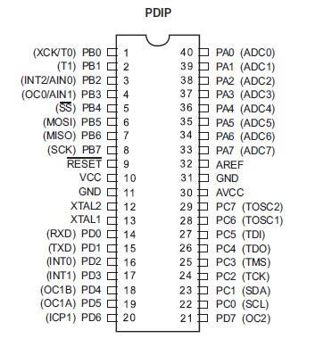

Figure 3:Atmega16 IC pin diagram

**Accelerometer**

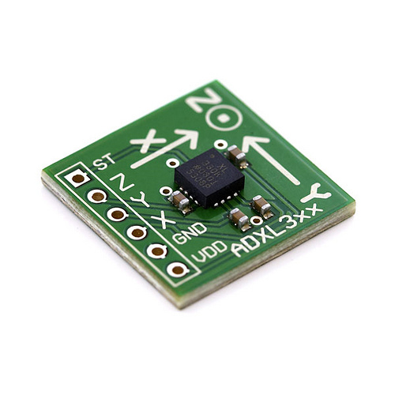

Figure 4: Accelerometer

An Accelerometer is a kind of sensor which gives an analog data while moving in X,Y,Z direction or may be X,Y direction only depend's on the type of the sensor.

We can see in the image that their are some arrow showing if we tilt these sensor's in that direction then the data at that corresponding pin will change in the analog form.

The Accelerometer having 6 pin-

1- VDD- We will give the +5volt to this pin

2- GND- We simply connect this pin to the ground for biasing.

3- X- On this pin we will receive the analog data for x direction movement.

4- Y- On this pin we will receive the analog data for y direction movement.

5- Z-  On this pin we will receive the analog data for z direction movement.

6- ST- this pin is use to set the sensitivity of the accelerometer

**RF COMMUNICATION MODULE**

The RF module, as the name suggests, operates at Radio Frequency. The corresponding frequency range varies between 30 kHz & 300 GHz. In this RF system, the digital data is represented as variations in the amplitude of carrier wave. This kind of modulation is known as Amplitude Shift Keying (ASK).

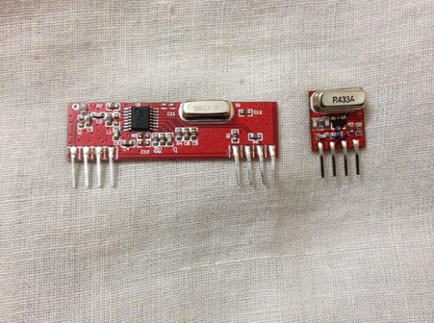

Figure 5: Transmitter and reciever

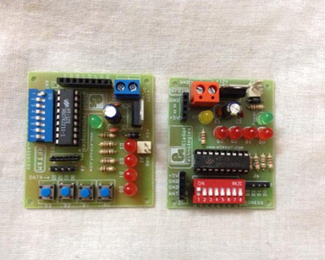

Figure 6: Transmitter and receiver module

Figure 1: Figure 1

Transmission through RF is better than IR (infrared) because of many reasons. Firstly, signals through RF can travel through larger distances making it suitable for long range applications. Also, while IR mostly operates in line-of-sight mode, RF signals can travel even when there is an obstruction between transmitter & receiver. Next, RF transmission is more strong and reliable than IR transmission. RF communication uses a specific frequency unlike IR signals which are affected by other IR emitting sources.

This **RF module** comprises of an **RF Transmitter** and an **RF Receiver**. The transmitter/receiver (Tx/Rx) pair operates at a frequency of **434 MHz**. An RF transmitter receives serial data and transmits it wirelessly through RF through its antenna connected at pin4. The transmission occurs at the rate of 1Kbps - 10Kbps.The transmitted data is received by an RF receiver operating at the same frequency as that of the transmitter.

The RF module is often used alongwith a pair of encoder/decoder. The encoder is used for encoding parallel data for transmission feed while reception is decoded by a decoder.  [HT12](http://www.engineersgarage.com/content/ht12e)E- [HT12D,](http://www.engineersgarage.com/content/ht12d) HT640-HT648, etc. are some commonly used encoder/decoder pair ICs.

**Applications:**

* Vehicle monitoring
* [Remote contro](http://en.wikipedia.org/wiki/Remote_control)l
* [Telemetr](http://en.wikipedia.org/wiki/Telemetry)y
* [Small-range wireless networ](http://en.wikipedia.org/wiki/Home_automation)k
* Wireless meter reading
* Access  [control system](http://en.wikipedia.org/wiki/Control_systems)s
* [Wireless home security system](http://en.wikipedia.org/wiki/Security_systems)s
* Area paging
* Industrial data acquisition system
* Radio tags reading
* RF contactless smart cards
* [Wireless data terminal](http://en.wikipedia.org/wiki/Data_terminals)s

**Pin Diagram**

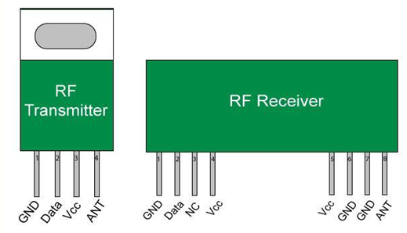

Figure 7: Pin diagrams

|  |  |  |
| --- | --- | --- |
| **Pin No** | **Function** | **Name** |
|  |  |  |
| 1 | Ground (0V) | Ground |
| 2 | Serial data input pin | Data |
| 3 | Supply voltage; 5V | Vcc |
| 4 | Antenna output pin | ANT |

Table 1: Pin name and function of transmitter

**RF Receiver**

|  |  |  |
| --- | --- | --- |
| **Pin No** | **Function** | **Name** |
|  |  |  |
| 1 | Ground (0V) | Ground |
| 2 | Serial data output pin | Data |
| 3 | Linear output pin; not connected | NC |
| 4 | Supply voltage; 5V | Vcc |
| 5 | Supply voltage; 5V | Vcc |
| 6 | Ground (0V) | Ground |
| 7 | Ground (0V) | Ground |
| 8 | Antenna input pin | ANT |

Table 2: Pin name and function of receiver

**LCD**

HD44780 based LCD displays are very popular among hobbyists because they are cheap and they can display characters. Besides they are very easy to interface with microcontrollers and most of the present day high-level compilers have in-built library routines for them.

**Required Theory**

All HD44780 based character LCD displays are connected through 14 pins: 8 data pins (D0-D7), 3 control pins (RS, E, R/W), and three power lines (Vdd, Vss, Vee). Some LCDs have LED backlight feature that helps to read the data on the display during low illumination conditions. So they have two additional connections (LED+ and LED-), making altogether 16 pin. A 16-pin LCD module with its pin diagraam is shown below.

[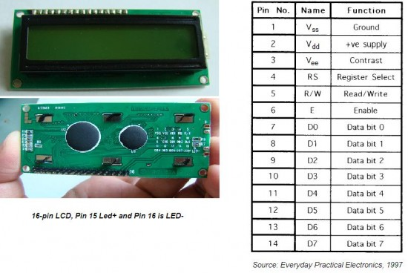](http://embedded-lab.com/blog/?attachment_id=771)

Table 3: LCD Pin names and function

|  |  |  |  |  |  |  |  |  |  |  |  |  |  |  |  |  |
| --- | --- | --- | --- | --- | --- | --- | --- | --- | --- | --- | --- | --- | --- | --- | --- | --- |
| First Line | 00 | 01 | 02 | 03 | 04 | 05 | 06 | 07 | 08 | 09 | 0A | 0B | 0C | 0D | 0E | 0F |
| Second Line | 40 | 41 | 42 | 43 | 44 | 45 | 46 | 47 | 48 | 49 | 4A | 4B | 4C | 4D | 4E | 4F |

Table 4: 16 Bits of LCD

**Control pins**

The control pin RS determines if the data transfer between the LCD module and an external microcontroller are actual character data or command/status. When the microcontroller needs to send commands to LCD or to read the LCD status, it must be pulled low. Similarly, this must be pulled high if character data is to be sent to and from the LCD module.

The direction of data transfer is controlled by the R/W pin. If it is pulled Low, the commands or character data is written to the LCD module. And, when it is pulled high, the character data or status information from the LCD registers is read. Here, we will use one way data transfer, i.e., from microcontroller to LCD module, so the R/W pin will be grounded permanently.

The enable pin (E) initiates the actual data transfer. When writing to the LCD display, the data is transferred only on the high to low transition of the E pin.

**Power supply pins**

Although most of the LCD module data sheets recommend +5V d.c. supply for operation, some LCDs may work well for a wider range (3.0 to 5.5 V). The Vdd pin should be connected to the positive power supply and Vss to ground. Pin 3 is Vee, which is used to adjust the contrast of the display. In most of the cases, this pin is connected to a voltage between 0 and 2V by using a preset potentiometer.

**Data pins**

Pins 7 to 14 are data lines (D0-D7). Data transfer to and from the display can be achieved either in 8-bit or 4-bit mode. The 8-bit mode uses all eight data lines to transfer a byte, whereas, in a 4-bit mode, a byte is transferred as two 4-bit nibbles. In the later case, only the upper 4 data lines (D4-D7) are used. This technique is beneficial as this saves 4 input/output pins of microcontroller. We will use the 4-bit mode.

For further details on LCDs, I recommend to read these two articles first from Everyday Practical Electronics magazine : How to use intelligent LCDs [Part 1](http://lcd-linux.sourceforge.net/pdfdocs/lcd1.pdf), and [**Part 2**](http://lcd-linux.sourceforge.net/pdfdocs/lcd2.pdf).

**Circuit Diagram**

Data transfer between the MCU and the LCD module will occur in the 4-bit mode. The R/W pin (5) of the LCD module is permanently grounded as there won’t be any data read from the LCD module. RC0-RC3 serves the 4-bit data lines (D4-D7, pins 11-14) of the LCD module. Control lines, RS and E, are connected to RC4 and RC5. Thus, altogether 6 I/O pins of the PIC16F688 microcontrollers are used by the LCD module. The contrast adjustment is done with a 5K potentiometer as shown below. If your LCD module has backlight LED, use a 68? resistance in series with the pin 15 or 16 to limit the current through the LED. The detail of the circuit diagram is shown below.

[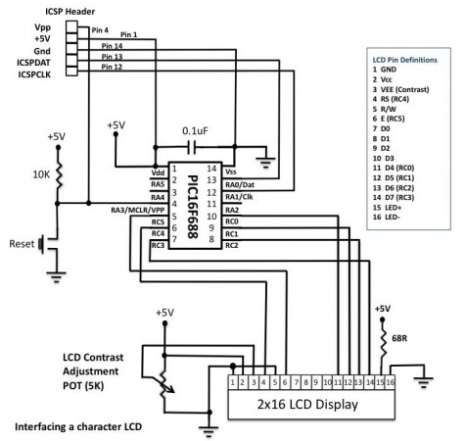](http://embedded-lab.com/blog/?attachment_id=685)

Figure 9: Block Diagram of LCD

For example, the Display ON/OFF Control command has the following fields,

|  |  |  |  |  |  |  |  |  |  |
| --- | --- | --- | --- | --- | --- | --- | --- | --- | --- |
| RS | R/W | D7 | D6 | D5 | D4 | D3 | D2 | D1 | D0 |
| 0 | 0 | 0 | 0 | 0 | 0 | 1 | D | C | B |
|  |  |  |  |  |  |  |  |  |  |

Table 5: Register Bits of LCD

Here, D4:D7 are 0’s, D3 is 1 and RS and R/W are held low. These are all constant values. They have to be used as such. But the, bits D0:D2 are all variables.

D = 0 – Turns the display OFF D = 1 – Turns ON the display

C = 0 – Turns the Cursor OFF C = 1 – Turns the Cursor ON

B = 0 – Character at the cursor is static B = 1 – Character at the cursor is blinking.

**DC MOTORS:**

**Introduction of DC Motor:**

A direct current or DC motor is a mechanically commutated electric motor powered from direct current (DC). It converts electrical energy into mechanical energy. It is one of two basic types of motors: the other type is the alternating current or AC motor. Among DC motors, there are shunt-wound, series-wound, compound-wound and permanent magnet motors.

**FIGURE OF DC MOTOR**

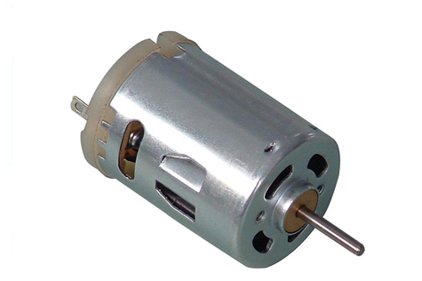

Figure 10: DC motor

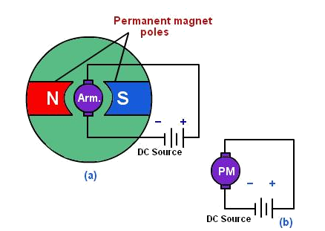

Figure 11: Internal architecture of DC motor

**Principle of operation :**

In any electric motor, operation is based on simple electromagnetism. A current-carrying conductor generates a magnetic field; when this is then placed in an external magnetic field, it will experience a force proportional to the current in the conductor, and to the strength of the external magnetic field. As you are well aware of from playing with magnets as a kid, opposite (North and South) polarities attract, while like polarities (North and North, South and South) repel. The internal configuration of a DC motor is designed to harness the magnetic interaction between a current-carrying conductor and an external magnetic field to generate rotational motion.

**How DC Motor works?**

Let’s start with how actually DC motor runs. Direction control of a DC motor is very simple; just reverse the polarity, means every DC motor has two terminals out. When we apply DC voltage with proper current to a motor, it rotates in a particular direction but when we reverse the connection of voltage between two terminals, motor rotates in another direction.

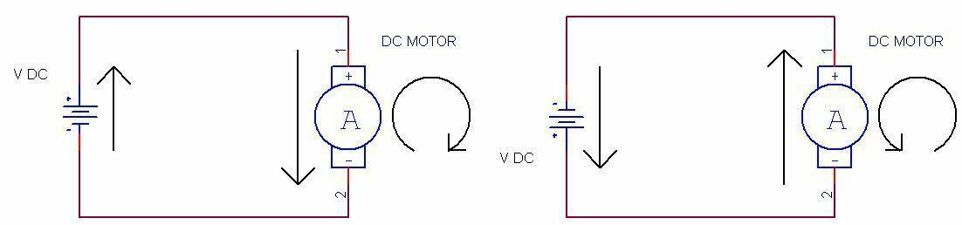

Figure 11: Working of DC motor

**Interfacing of DC Motor**

Similar is true for another motor connected to Out3 and Out4 of L293d and can be controlled through IN3 and IN4. This is all about controlling direction of DC motor using L293d and ATmega16.

To control the speed of DC motor one can use a Pulse Width Modulated signal on Enable1 and Enable2 pins of L293d; this will result in controlled power input on motor, so speed is controlled.

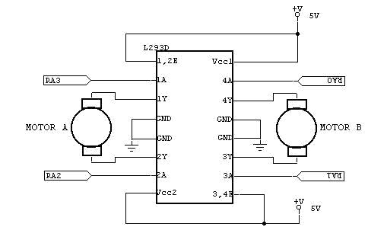

Figure 12: Interconnection between DC motors and IC L293d

**CHASIS BOARD**

1. Chasis board provides a base to robot.
2. Wheels, sensors and controller board are attached to it.

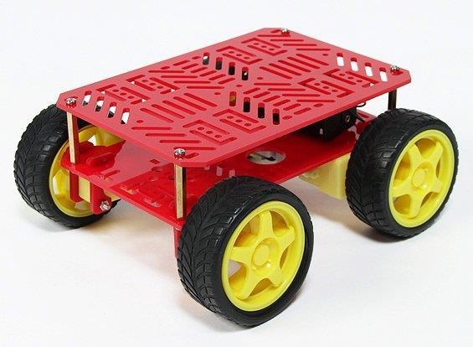

**In the RF Modulation section**

**Transmitter**

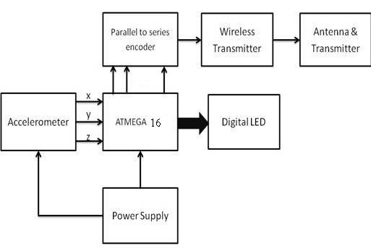

Figure 13: Transmitter block

**Comparator**:-

For the purpose to change the analog voltage into digital we use comparator which compare that analog voltage to a reference voltage and give a particular high or low voltage.

|  |
| --- |
| [http://1.bp.blogspot.com/-7C753l0qSlA/Tyg4GW3thvI/AAAAAAAAALw/1jXyyixPtAE/s200/LM324_circuit.jpg](http://1.bp.blogspot.com/-7C753l0qSlA/Tyg4GW3thvI/AAAAAAAAALw/1jXyyixPtAE/s1600/LM324_circuit.jpg) |
|  |
| Figure 14: LM324 IC |

The figure shown here is comparator IC. The pin 1,7,8 and 14 are use to give out put to the microcontroller.We should connect a reference voltage to the -ve terminal for high output when input is high(+ve terminal for high output when input is low) from the LM324 IC.

In this circuit we compare the data from x with two terminal one for positive x direction and negative x direction and same for y direction.

|  |
| --- |
| [http://1.bp.blogspot.com/-T6SDfe98VzQ/TvYNp8UHxYI/AAAAAAAAAGI/64QwkNbHkxg/s200/HT12E.jpg](http://1.bp.blogspot.com/-T6SDfe98VzQ/TvYNp8UHxYI/AAAAAAAAAGI/64QwkNbHkxg/s1600/HT12E.jpg) |
|  |
| Figure 15: HT12E encoder |

**Encoder(HT12E IC):**

The HT12E is an 4bit encoder which encode the input data applied on it .The pin description of the HT12E is shown in the figure .

* pin (1 to 8) A0-A7 known as address bits so we do not need to consider them.
* pin no (9 and 18) are use to bias the IC  as pin-18 as VCC and pin-9 as GND.
* pin - 17 is connected to the rf transmitter module Din.
* pin-16 and pin-15 are connected by an Osc resistor known as Roscc(1.1 Mohm)
* pin-14 is connected to ground to enable the transmitt.
* pin-13 to pin-10 are known as AD0 to AD3 those having the 4bit data which is required to transmit.

**RF Transmitter Module(TX):-**

The transmitter module is working  on the frequency of 433MHz and is easily available in the market at the cost of 250rs .

* The vcc pin is connected to the +terminal in the circuit.
* The data pin is connected to the HT12E(pin no-17) that is transmitted or we can say that encoded data.
* The next pin is shown in figure is GND that is connected to the ground terminal.
* Now the last pin ANT this is connected to a small wire as an antenna.

**Receiver**

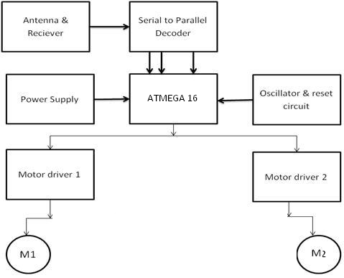

Figure 16: Receiver block

1. Receiver
2. Decoder(HT12D)
3. Process(microcontroller atmega16)
4. Actuator (Motor driver L293D)

**RF Receiver Module(RX):**

The RF receiver module will receive the data which is transfered by the gesture device. It is also working as similar to the transmitter module-

[http://4.bp.blogspot.com/-FUc2wVutIjc/T6A6Qa3q35I/AAAAAAAAAZo/7kFvX1_IHvE/s200/rf-tx-rx-433-250x250.jpg](http://4.bp.blogspot.com/-FUc2wVutIjc/T6A6Qa3q35I/AAAAAAAAAZo/7kFvX1_IHvE/s1600/rf-tx-rx-433-250x250.jpg)

* Connect the +vcc pin to the 5volt terminal
* Connect the ground pin to the ground terminal
* The data pin is then connected to the HT12D (pin-14)
* So that we can get the decoded 4 bit data

**Decoder (HT12D):-**

In a very simple way we can say that an HT12D converts that serial data into parallel which is received by the rf receiver module.The input data is decoded when no error or unmatched codes are found. A valid  transmission in indicated by a high signal at VT pin that is pin no 17.

|  |
| --- |
| [http://4.bp.blogspot.com/-hxOaB9YztEg/T6A9wxd3fGI/AAAAAAAAAZ8/HWSge35WNyg/s200/HT12D_1.jpg](http://4.bp.blogspot.com/-hxOaB9YztEg/T6A9wxd3fGI/AAAAAAAAAZ8/HWSge35WNyg/s1600/HT12D_1.jpg) |
| Figure 17: HT12D |
|  |

* pin 18     : It is use to give the +vcc or biasing to the  IC HT12D this pin is connected with the +5 volt
* Pin 17     : It is the valid transmission pin it will high when the transmission is ok so that we connected this pin to an led for indication.
* Pin 16-15: we connect these two pin directly by a 51k resistor
* Pin 14     : This pin is connected with the rf receiver module data pin to receiving the serial data.
* Pin 10-13: These pins are data pin which is transferred by the gesture module

**Code of the program**

The following C code represents the accelerometer controlled robotic car using RF communication.

* The accelerometer controlled robot car requires two development boards ---

One that acts as the **transmitter** and the other that acts as the **receiver** and is placed within the car.

* Hence given below are the two coding required for (a) the transmitter, and (b) the receiver.

**Application**

1.       Military application to control robotics.

2.       Medical application for surgery purpose.

3.       Construction application.

4.       Industrial application for trolley control, lift control, etc.

5. Spying purposes.

**CONCLUSION**

We found that the RF module can be used for communication between two terminals at a long range of distances, and hence can be utilized to control any robot from significant distances to perform the required task without revealing the source of control

And accelerometer can be used to control the motion of your hand ie gesture of your hand to run any robot accordingly.

**References**

<http://www.i3indyatechnologies.com/training/summer-training/training-details-delhi-for-students.html>

<http://embedded-lab.com/blog/?p=203>

<http://embedjournal.com/interfacing-lcd-module-part-1/>

<http://www.roboshop.in/gesture-controlled-using-accelerometer>

<http://www.engineersgarage.com/contribution/accelerometer-based-hand-gesture-controlled-robot>

**Appendix**

**Code**

//Transmitter Code

#include<avr/io.h>

#define F_CPU 8000000UL

#include<util/delay.h>

#define lcd PORTC

#define rs 0

#define rw 1

#define en 2

void lcd_init();

void lcd_command(unsigned char);

void lcd_data(unsigned char);

void lcd_string(unsigned char *str);

void lcd_number(unsigned int);

void adc_init();

unsigned int adc_read(unsigned char channel);

int main()

{

DDRA=0X00;

DDRC = 0XFF;

DDRB= 0XFF;

lcd_init();

adc_init();

unsigned int x,y,z;

while(1)

{

x=adc_read(1);

y=adc_read(2);

z=adc_read(3);

lcd_command(0xc0);

lcd_string("z:");

_delay_ms(100);

lcd_command(0xc6);

lcd_number(z);

_delay_ms(100);

lcd_command(0x80);

lcd_string("x:");

_delay_ms(100);

lcd_command(0x86);

lcd_number(x);

_delay_ms(100);

lcd_command(0x89);

lcd_string("y:");

_delay_ms(100);

lcd_command(0x8f);

lcd_number(y);

_delay_ms(100);

//STILL

if ((x>390 && x<425) && (y>370 && y<440) && (z>280 && z<335))

{

PORTB = 0b00000000;

lcd_command(0xc8);

lcd_string("Still");

_delay_ms(5);

}

//forward

if ((x>370 && x<420) && (y>285 && y<350)&& (z>300 && z<425))

{

PORTB = 0b00001010;

lcd_command(0xc8);

lcd_string("Frwad");

_delay_ms(5);

}

//backward

if ((x>400 && x<450)&&(y>450 && y<485)&& (z>300 && z<423))

{

PORTB = 0b00000101;

_delay_ms(5);

lcd_command(0xc8);

lcd_string("Backd");

_delay_ms(5);

}

//right

if ((x>450 && x<490)&&(y>370 && y<427)&& (z>310 && z<380))

{

PORTB = 0b00001001;

_delay_ms(5);

lcd_command(0xc8);

lcd_string("right");

_delay_ms(5);

}

//left

if ((x>300 && x<350)&&(y>320 && y<430)&& (z>310 && z<370))

{

PORTB = 0b00000110;

_delay_ms(5);

lcd_command(0xc8);

lcd_string("Left");

_delay_ms(5);

}

}

void lcd_init()

{

_delay_ms(5);

lcd_command(0x02);

lcd_command(0x28);

lcd_command(0x06);

lcd_command(0x0c);

}

void lcd_command(unsigned char com)

{

lcd = com & 0xF0; //send higher bit

lcd &= ~(1<<rs); //rs =0

lcd &= ~(1<<rw); //rw =0

lcd |=(1<<en); //en =1

_delay_ms(5);

lcd &= ~(1<<en); //en =0

_delay_ms(5);

lcd = (com<<4) & 0xF0; //send lower bit

lcd &= ~(1<<rs); //rs =0

lcd &= ~(1<<rw); //rw =0

lcd |=(1<<en); //en =1

_delay_ms(5);

lcd &= ~(1<<en); //en =0

_delay_ms(5);

}

void lcd_data(unsigned char value)

{

lcd =value & 0xF0; //send higher bit

lcd |= (1<<rs); //rs =1

lcd &= ~(1<<rw); //rw =0

lcd |=(1<<en); //en =1

_delay_ms(5);

lcd &= ~(1<<en); //en =0

_delay_ms(5);

lcd =(value<<4) & 0xF0; //send lower bit

lcd |= (1<<rs); //rs =1

lcd &= ~(1<<rw); //rw =0

lcd |=(1<<en); //en =1

_delay_ms(5);

lcd &= ~(1<<en); //en =0

_delay_ms(5);

}

void lcd_string(unsigned char *str)

{

char i=0;

while(str[i]!='\0')

{

lcd_data(str[i]);

i++;

}

}

void lcd_number(unsigned int value)

{

unsigned int d=0;

lcd_command(0x04); //auto decrement mode

if (value==0)

{lcd_data(d+48);}

while(value!=0)

{

d=value%10;

lcd_data(d+48);

value=value/10;

}

lcd_command(0x06); //auto increment mode

}

void adc_init(void)

{

ADMUX|=0x40;

ADCSRA|=(1<<ADEN)|(1<<ADPS2)|(1<<ADPS1)|(1<<ADPS0);

}

unsigned int adc_read(unsigned char ch)

{

//ch=ch&0b00000111;

ADMUX=0x40|ch;

ADCSRA|=(1<<ADSC);

while(!(ADCSRA &(1<<ADIF))){} //ADCSRA=ADCSRA|(1<<ADIF)

return ADC;

}

//Receiver Code

#define F_CPU 8000000UL

#include<util/delay.h>

#include<avr/io.h>

int main()

{

DDRB =0XFF;

DDRA= 0X00;

_delay_ms(10);

while(1)

{

if(PINA==0b00001010)

{

PORTB=0b00001010;

_delay_ms(10);

}

if(PINA==0B00000101)

{

PORTB=0B00000101;

_delay_ms(10);

}

if(PINA==0B00000000)

{

PORTB=0B00000000;

_delay_ms(10);

}

if(PINA==0B00001001)

{

PORTB=0B0000100;

_delay_ms(10);

}

if(PINA==0b00000110)

{ PORTB=0b00000010;

_delay_ms(10);

}

}

return 0;

}